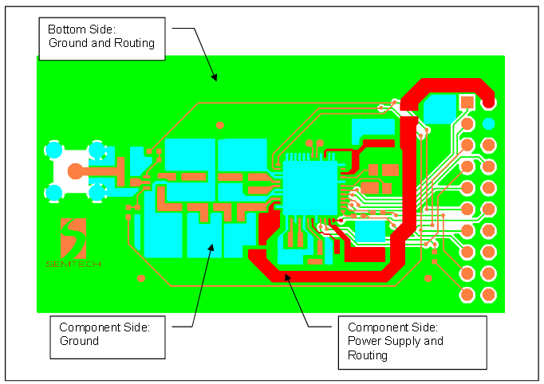

* power supply trace on the component I s made quite thick so as to present as low as impedance trace as possible.
* Large areas of ground on this side of the board provide a low impedance path for decoupling.
* Wherever possible the bottom (copper) side of the board should allow for a solid ground plane under the RF circuitry.
* the PCB thickness should not exceed 0.8mm - 1.00mm
* Minimize current loops on PCB layouts by decoupling as close to the port being decoupled to ground as possible.
* each circuit block or port has its own decoupling capacitor.
* Ensure that each decoupling capacitor has its own via connection to ground. As a rule of thumb, components should not share vias.
* 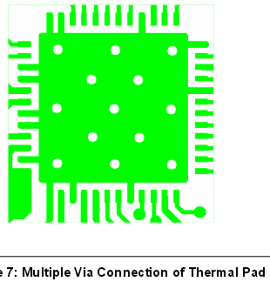Figure 7 illustrates the multiple via (or “well stitched”) connection of the thermal relief pad to the main (inner) ground layer.
* **RF Transmission Lines**: Lines should be kept as far apart as possible, and should not be routed in close proximity for extended distances.
* **High-Speed Digital Signal Lines**: These lines should be routed separately on a different layer than the RF signal lines, to prevent coupling. Digital noise (from clocks, PLLs, etc.) can couple onto RF signal lines, and these can be modulated onto RF carriers. Alternatively, in some cases digital noise can be up/down-converted.
* **VCC/Power Lines**: These should be routed on a dedicated layer. Adequate decoupling/bypass capcitors should be provided at the main VCC distribution node, as well as at VCC branches. The choice of the bypass capacitances must be made based on the overall frequency response of the RF IC, and the expected frequency distribution nature of any digital noise from clocks and PLLs. These lines should also be separated from any RF lines that will transmit large amounts of RF power.
* two layer, the top layer should include the power stage, RF signal lines and RF components. Then the bottom layer must be the ground plane.
* Draw the RF signal lines quite separately. If they are adjacent to eachother, then crosstalk may occur. (Crosstalk : Undesired transfer of signals between or among two lines such as telephone lines, data lines, or system components. )
* When you finish all the layers, fill the empty spaces with copper pour that is connected to the ground. Place vias that are connected to the ground layer with a distance of λ/20 cm between eachother.
* 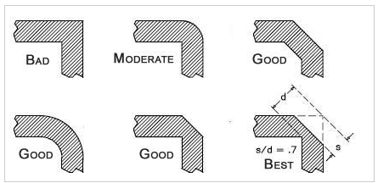
* Decouple the supply voltage. An example circuit and its PCB is shown below. Consider that the capacitor with a smaller capacitance is placed nearer to the IC.
* 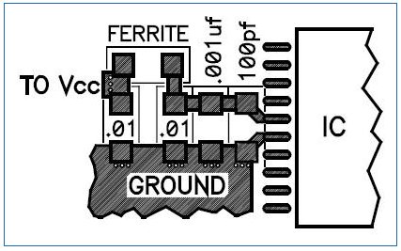
* 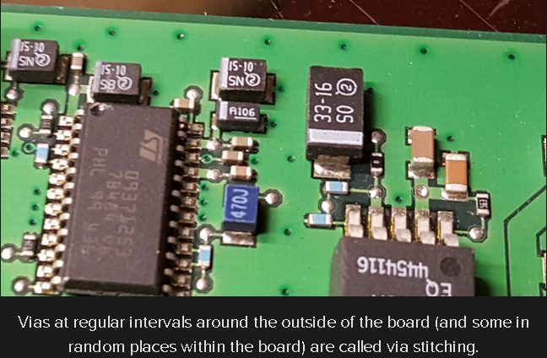
* trace that is near the edge of the board and farther from a ground plane layer will radiate more electromagnetic interference. Via stitching refers to putting a ring of vias attached to the ground plane all the way around the edge of the PCB (or as much as possible). n addition, a healthy dose of vias should connect the ground pour to the ground plane This prevents accidental antennas, and also ensures that the whole ground stays at the same potential all the time.
* The ferrite bead is usually used when connecting a switching power supply to the power plane, as it isolates the noise from the supply, so it is placed (along with a decoupling capacitor) next to the power supply output.
* Keep Traces Short - The crystal should be as close as possible to the microcontroller, with the wires going directly between the two. Every extra millimeter is more changing electric field and more emissions. A UART can have much longer wires because the signal doesn’t change as fast, and the positive voltage rails can meander all over.
* A two-layer board can achieve 95% of the effectiveness of a four-layer board by emulating what makes a four-layer board better:
  + Make an extra effort to route ground underneath power.
  + Grid power and ground, but be careful not to create unneeded common impedance connections or to violate an intended isolation, such as between high-power and digital grounds. See section 2.2.3, Gridding to Create Planes.
  + Route returns for direct connections to the processor I/Os directly under the signal trace. Gridding is aspace-effective way of doing this. See section 2.2.3, Gridding to Create Planes.
  + Under the microcomputer, build a solid plane for ground that bypassing components and the oscillator loop can be tied to. Tie this ground to the ground pin and the power-supply bypass capacitor. This is called a microcomputerground, which is discussed in section 2.1.3.
* 2.2.3 Gridding to Create Planes

Gridding is the most critical design technique for two-layer boards. Much like a power utility grid, gridding is a network of orthogonal connections between traces carrying ground. It effectively creates a ground plane, which provides the same noise reduction as on four-layer boards. It serves two purposes:

* Emulates the ground plane of a four-layer board by providing a ground return path under each of the signal traces
* Lowers the impedance between the microcomputer and the voltage regulation

Gridding is done by expanding any ground traces and using ground-fill patterns to create a network of connections to ground across the PCB. For example, a PCB has most of the topside traces running vertically and most of the bottom traces running horizontally (see Figure 7). This already is working against having the return run directly under signal. First, every ground trace is expanded to fill up as much of the empty PCB space as possible. Then, all the remaining empty space is filled with ground. Place through holes where top-side traces cross bottom-side traces. Then do the same to the ground-fill patterns. Ground-fill patterns make a better contribution to the grid if they are tied to ground at both ends. A ground-fill-pattern geometry connected at only one point is just a ground shield, but if connected at two or more points, it becomes a conductor, and, therefore, becomes a contributor in the grid.

* Grid as much as possible on a two-layer board. Look for places where small changes in the layout would allow another connection to be made in the grid.
* Use as many through holes as can physically fit.
* Lines do not have to be orthogonal, or of the same width.

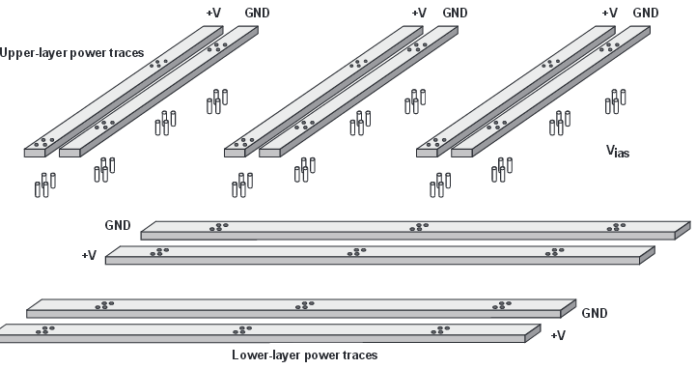8

An example of gridding ground only to achieve the effect of a ground plane is shown in Figure 8. Note how the changes made

in order to implement this were minor, indicating how a small effort can have a large payback.